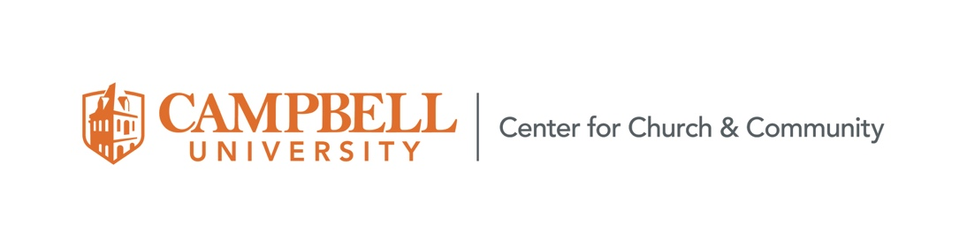
Ethical Framework for Engagement
The Office of Community Engagement at Campbell University helps students, faculty and staff create “purposeful lives and meaningful service” and to live out the mission of the university to educate students by providing “opportunities for servant leadership and community engagement, with emphasis on underserved communities,” while students “develop moral courage, social sensitivity and ethical responsibility.”
We believe that learning through service and community engagement has the potential to
heighten a student’s “moral courage, social sensitivity and ethical responsibility”; however,
service may also reinforce power dynamics, abuse resources, impose hardship on communities, and damage relationships if performed with the wrong approach or in the wrong spirit.
To assist with the ethical responsibilities of community engagement, the following document provides principles to guide meaningful service, then asks questions to aid in development of programs and activities across the university for all levels and divisions.
Guiding Principles
The goal for community engagement is to work as equal partners with the community in mutually beneficial local relationships that are respectful of social, economic, and environmental concerns which build sustainable capacity, ensure quality, maintain credibility, and engender trust in the community. If performed in a spirit of humble reciprocity, we believe community engagement has the potential to heighten a student’s understanding of God, themselves, and the World.
Therefore, community engagement should be guided by the following principles:
Moral Courage
• Justice: Engagement often focuses on communities where equity is lacking. When we work in underserved and marginalized populations, we strive to work toward equality and justice. We recognize the risk of paternalism, exploitation, and neocolonial behavior by those from resource- rich environments when engaging with partners in low material resource settings.
• Inclusivity: We celebrate diversity and inclusivity by recognizing the linked humanity of all peoples as children of God without exception or exclusion and focus on ways to encourage human thriving. We work to eliminate barriers that prevent full participation of all people in outreach, learning, or research. This involves practicing respect for differences as an on-going learning practice.
• Humility and Openness: “Sometimes the best service we can perform is truly learning about others in humility and reciprocity.” We strive to nurture such openness through attentive listening to the needs of the community, that we may learn as we work with the community.
Social Sensitivity
• Community Driven: In order to “lead with purpose,” we must interact with the community with a sense of humility and social sensitivity. Our goal is to “follow first” by being guided by the community. Educational or service agendas should not be prioritized over community safety, autonomy, and dignity. • Reciprocal Partnerships: We seek to work alongside communities as equal partners. We strive to create long-term associations that mutually benefit the students, Campbell University, and the community in which we are engaged.
• Empowerment and capacity building: We support communities in developing the tools and resources they need to support themselves. We ask – rather than tell – how we can contribute, with a goal of affecting positive, long-lasting change.
Ethical Responsibility
• Preparation: We ensure that participants are adequately prepared to work within their limitations and capabilities. We prepare for engagement before, during and after with adequate planning and participant orientation, to ensure skills, knowledge, and mindsets.
• Strong Communication: Clear routes of communication between students, mentor, and community should be established and maintained. Partners should feel empowered to define their role; roles and expectations should be set in writing. Agreements should be re- evaluated at regular intervals, with all parties giving feedback.
• Sustainability: Sustainability can be thought of in two ways: projects should build the on-going capacity of the community, and service should be sustainable in resource use and time/labor allotted.
• Financial Transparency: Financial ethics of transparency and fiscal responsibility must be practiced on both sides. There should be no conflicts of interest.
• Research: research questions are informed by the needs and wants of those who are affected by them, and the results, conclusions, and benefits are shared with the community of study. Necessary research permissions have been obtained.
Applying These Principles:
Questions for Preparing and Developing Community Engagement Activities.

In order to achieve the above values, the following questions should be determined before planning any service or community engagement project:

Community Expectations
- What are the needs of the community? Has the community shared a need or indicated a desire for the project?
  - Is the mission of the community partner compatible with the mission of the university?
  - Have goals been discussed openly and expectations made clear?
- How is the community involved in the design and implementation of the project?
  - Does the project build capacity in support structures already available in the community?
  - What does the community gain by participating in the project?
  - How does the proposed project address a need expressed by the community?
    - Are project goals clearly articulated?
    - How will “success” of these goals be measured or assessed?
- What resources (time, personnel, space, expenses, etc.) are required by the community?
  - How are resources being planned for or appropriated?
  - What ongoing resources are needed?
  - Has training or orientation been discussed and planned for? Who will do this?
- Are all parties practicing truthfulness and transparency? Are we avoiding conflicts of interest?
- What challenges might the community experience while participating in the project?
- What happens after the engagement to ensure sustainability and ongoing capacity building?

Campbell Expectations
- Is the mission of the University compatible with the mission of the community partner?
- Are lines of communication clear and equal?
  - Who are the stated contacts for the community and the university?
  - Is there sustainable contact beyond one person?
- Have goals been discussed openly and expectations made clear?
  - How is Campbell engaging the community in the design and implementation of the project?
  - Have the “Community Expectations” above been discussed with the partner?
  - Has training or orientation been discussed and planned for? Who will do this?
- What do students learn?
  - Are goals for the activity/learning outcomes articulated?
  - How does the activity help institutional effectiveness or student learning?
  - Who will evaluate the students?
  - What is required for completion?
- Does the level of student knowledge/skill match the needs for participating in the project?
- Are participants properly oriented for respect, humility, and conduct [trained to navigate issues of team building, power and privilege, cultural adjustment, cultural bias, and conflict resolution]?
- What resources (time, personnel, space, expenses, etc.) are required from Campbell?
  - How are these being planned for or appropriated?
  - What ongoing resources are needed?

Policies
- Approvals: Schools and programs should register engagement; students and clubs should seek approval for projects from the Community Engagement office.
- Have the goals of the engagement and roles of all participants been clearly defined in writing?
- Is a code of conduct and behavior understood by participants and partners?
  - Have societal norms, cultural norms, and environmental conditions been incorporated into the code of conduct?
  - Are there opportunities for evaluation on both sides?
- Are standards for health, safety, and security of the participants understood?
  - Have all authorizations (research, permits, background checks, etc.) been secured for the activity?
  - Have policies been developed to protect children/vulnerable populations with whom CU representatives may interact?
  - What waivers, protections, etc. are in place to ensure safety of participants?
  - Have emergency contacts been established for both parties?
  - Is transit properly coordinated and authorized?
- If research is being performed, are expectations clear?
  - Is the research designed in collaboration with the community with benefits directed toward the community?
  - Will the community have ownership of any research/knowledge?
  - How will final research products (reports, audio/visual products, presentations, etc.) be created and distributed?
  - What processes are there for sharing such results with partners?
While an academic unit may have the autonomy to plan outreach on its own that engagement must match the standards established by the Community Engagement Office.

Adopted: August 2020

